**AI/ML**

**LAB MANUAL**

**Disclaimer: The content is curated from online/offline resources and used for educational purpose only**

**Gender Bias in Exam Performance – A Hypothesis Testing Approach**

**Objective:**

To analyze whether there is a significant difference in exam performance between male and female students using statistical hypothesis testing.

**Equipment Required:**

* Computer with Python and Jupyter Notebook installed
* Dataset: Students Performance in Exams (<https://www.kaggle.com/datasets/spscientist/students-performance-in-exams>)
* Python Libraries: pandas, numpy, matplotlib, seaborn, scipy

**Prerequisites:**

* Basic understanding of Python programming
* Knowledge of statistics, including hypothesis testing
* Familiarity with pandas for data manipulation
* Understanding of data visualization using matplotlib and seaborn

**Problem Statement:**

The objective of this study is to investigate whether gender plays a significant role in the academic performance of students in mathematics, reading, and writing. By applying hypothesis testing techniques, we aim to determine if there is a statistically significant difference in the scores of male and female students, which may indicate potential gender biases in educational outcomes.

**Code/Procedure:**

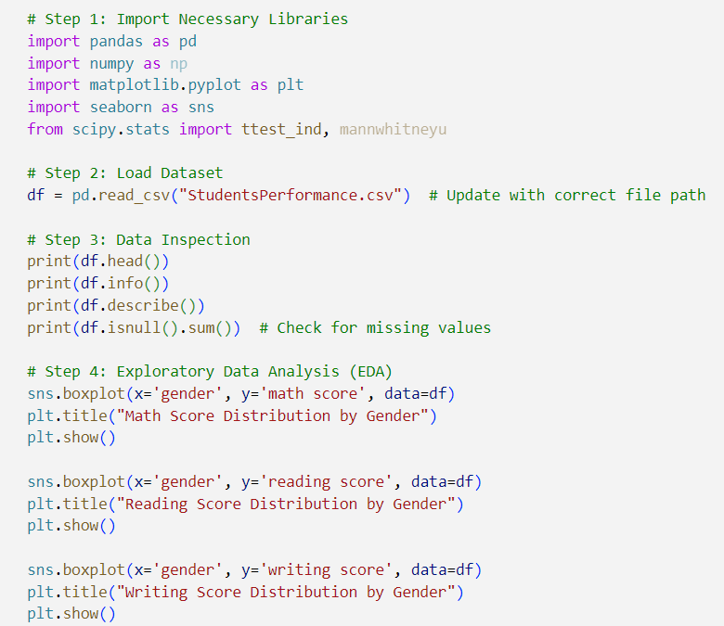

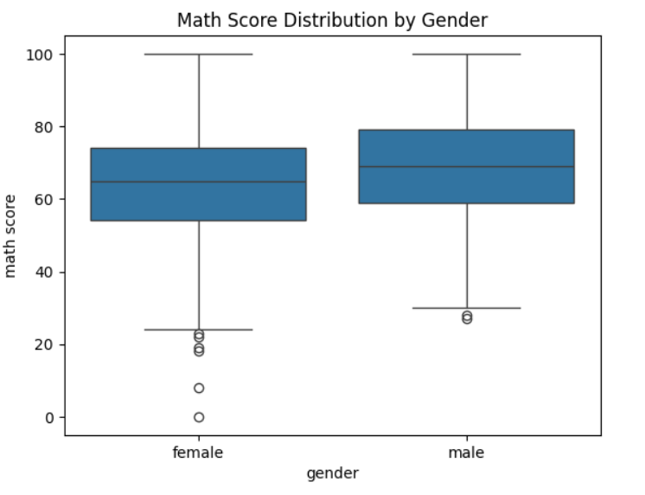

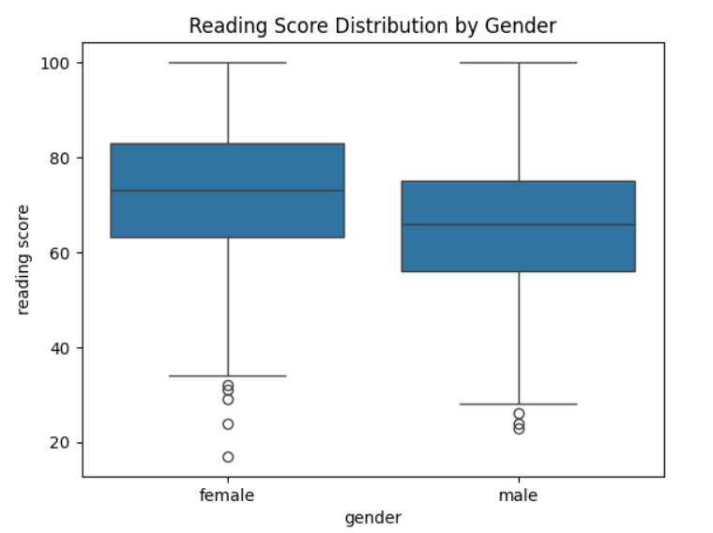

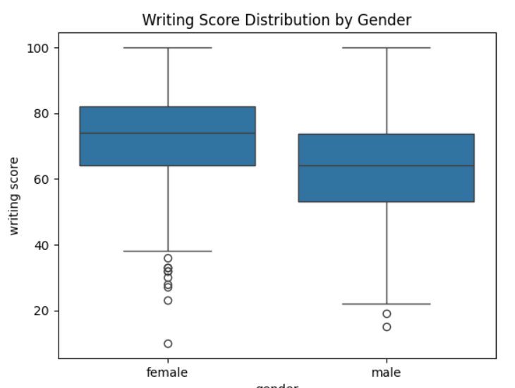

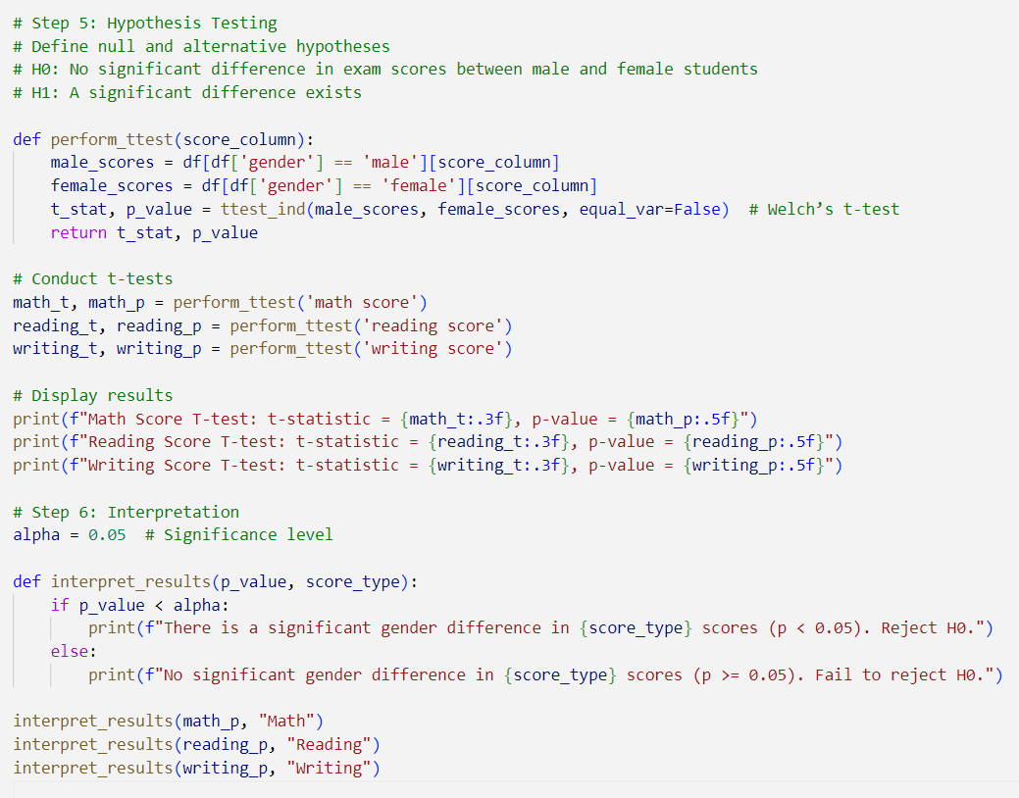

**Output:**

